Payment Broker PMX 8

Migration to FlexCloud

High Level Solution

Document Information

|  |  |
| --- | --- |
| Software Version: |  |
| Publication Date: |  |
| Catalog Number: |  |
| Security Level: | Level 2 - Sensitive |
| Creation Date: | 8/7/2025 9:49:00 AM |
| Account/FOP: |  |
| Author: | Vitalie Dicusara |
| Editor: |  |
| Last Edit Date: | 8/7/2025 9:49:00 AM |
|  |  |
| Template: | Universal1Side.dot |

Contents

1. Introduction 3

1.1. Version History 3

1.2. Acronyms 3

1.3. Overview 3

1.4. Description and Scope 4

1.4.1. Payment Broker Description 4

1.4.2. Requirements Summary 4

1.4.3. Request Description 4

1.4.4. Scope 5

2. Solution 7

2.1. Payment Broker Architecture 7

2.1.1. High Level System Architecture 7

2.1.2. High Level Integration Architecture 7

2.2. Current Active – Passive (A/P) On-Prem Architecture 8

2.3. Active – Passive (A/P) FlexCloud-Based Architecture 11

2.4. Software Components 12

2.5. Amdocs Foundation Components 14

2.6. PMX Upgrade Plan 15

3. Assumptions, Dependencies 17

3.1. Assumptions 17

3.1.1. RPL 9.3.110 Certification on FlexCloud 17

3.1.2. Operational Changes 17

3.1.3. Release – DB & APP 17

3.2. Dependencies 18

3.2.1. Dependent PIDs on PMX Upgrade 18

3.2.2. Impacted applications 18

3.2.3. Impacted interfaces 18

3.2.4. CSI migration to FlexCloud 19

4. Traceability 20

5. Operational Impact 21

# Introduction

## Version History

|  |  |  |  |
| --- | --- | --- | --- |
| AUTHOR NAME | VERSION NUMBER | REVISION DATE | SUMMARY OF CHANGE |
| Vitalie Dicusara, Dan Kimmel | 1.1 | 5/7/2025 | Baseline Version |
| Vitalie Dicusara | 1.2 | 7/31/2025 | Updated for FlexCloud |
|  |  |  |  |

## Acronyms

|  |  |  |
| --- | --- | --- |
| Acronym | Term | Description |
| PB | Payment Broker | The application handled by the project. |
| CSI | Common Services Interface | The gateway used for communication between different interfaces |
| TRB | Transaction Broker | This module is a daemon process used for real time interface between the biller and Payment Broker |
| API | Application Programming Interface | The Java based module which provides the ability for external requests to be executed through a server application |
| TCP/IP | Transmission Control Protocol and Internet Protocol | Used for communication according to defined standard |
| WS | Web services | Web based services |
| W/L | Weblogic | Component which enables the WS |
| Infra | Infrastructure | The team which supports all infrastructure related activities |
| TLG | Telegence | The Biller |
| E/// | Ericsson | Balance manager |

## Overview

The Payment Broker (PB) application currently operates on outdated infrastructure, including Red Hat Enterprise Linux (RHEL) OS version 6.x and Oracle Enterprise Database version 11g. Additionally, it relies on legacy third-party software and components such as WebLogic, Java, Perl, and Ant, many of which are no longer supported and lack available security patches.

While ATT has extended support for RHEL and Oracle, the upgrade of the PB application to PMX is a complex multi-release endeavor that is projected to span approximately one year. This upgrade process necessitates meticulous planning and preparation to ensure successful execution.

## Description and Scope

### Payment Broker Description

The Payment Broker (PB) serves as a middleware pass-through component, facilitating various services essential for managing prepaid monetary balances, feature offers, and query operations. The PB solution is built upon the Amdocs Replenishment Manager (RPL) framework, ensuring robust and scalable performance.

Key functionalities of the Payment Broker include:

* **Addition of New Offers:** Supports the integration of both limited and unlimited offers into the system, enhancing the flexibility and attractiveness of service plans.
* **Removal of Offers:** Enables the deletion of existing offers, whether limited or unlimited, ensuring the system remains up-to-date with current service offerings.
* **Extension of Existing Offers:** Facilitates the prolongation of active offers, both limited and unlimited, allowing for continued customer engagement and satisfaction.
* **Enrollment of Existing Offers:** Manages the subscription process for existing offers, ensuring seamless customer onboarding for both limited and unlimited plans.
* **De-enrollment of Existing Offers:** Handles the unsubscription process, providing customers with the option to opt-out of previously enrolled offers.
* **Barring Notifications:** Triggers notifications to customers in cases where monthly payments are not fulfilled, ensuring timely communication and service management.
* **Auto-Renewal Mechanism:** Implements an end-of-day (EOD) process for automatic renewal of services, maintaining uninterrupted service continuity.
* **Query Allowance:** Provides query services to retrieve information related to allowances, ensuring customers have access to accurate and up-to-date data.

The actual prepaid subscriber balance and offers (rate plans, features) are stored in Ericsson's system (E///) and not in the Payment Broker. The Payment Broker updates the subscriber details present in E/// in various business flows. It interfaces with multiple systems and components, including CSI (Common Services Interface), EDD (Enterprise Data Directory), and TLG (Telegence), to perform its functions.

### Requirements Summary

Upgrade the Payment Broker (PB) core version to 9.3.x, migrate the Red Hat Enterprise Linux (RHEL) operating system to version 8.x, upgrade the Oracle Database Enterprise Edition (DB EE) to version 19c on RHEL 8.x, and update all other third-party software components to ensure compliance with AT&T's Technical Security Standards (TSS).

### Request Description

The Payment Broker (PB) application currently operates on outdated infrastructure, including Red Hat Enterprise Linux (RHEL) OS version 6.x, Oracle Enterprise Database (DB) version 11g, and various legacy third-party software components such as WebLogic, Java, Perl, and Ant. Many of these third-party software components are no longer supported, and security patches are unavailable for some.

To address these issues, the PB application requires code updates and configuration adjustments as part of the upgrades to the OS, DB, and other third-party software. The upgrade process will include in-place upgrades for disaster recovery (DR), controlled failover, and in-place upgrades for the Intel C/C++ compiler, Apache Axis, OpenSSH, OpenSSL, Oracle Client, Oracle RAC Golden Gate, among others.

Additionally, the project will upgrade all supporting tools used to maintain the application.

The upgrade plan for the Payment Broker (PB) application involves several critical enhancements to ensure compliance with AT&T's Technical Security Standards (TSS) and to leverage the latest technological advancements. The proposed upgrades are as follows:

1. **PB Core Version Upgrade:**
   * **Target Version:** Upgrade the PB core version to 9.3.x.
   * **Benefits:** This upgrade will enhance performance, security, and compatibility with modern systems, ensuring the application remains robust and efficient.
2. **Red Hat Enterprise Linux (RHEL) OS Upgrade:**
   * **Target Version:** Upgrade from RHEL OS 6.x to RHEL OS 8.x.
   * **Features of RHEL 8.x:** RHEL 8.x offers improved security, stability, and support for cloud deployments. It includes enhanced capabilities, better system performance, and support for modern hardware architectures.
   * **Benefits:** This upgrade will provide a secure and consistent foundation for the PB application, facilitating faster workload delivery and improved system reliability.
3. **Oracle Database Enterprise Edition (DB EE) Upgrade:**
   * **Target Version:** Upgrade from Oracle DB EE 11g to Oracle DB EE 19c on RHEL 8.x.
   * **Features of Oracle DB EE 19c:** Oracle 19c includes advanced features such as improved performance, enhanced security.
   * **Benefits:** Upgrading to Oracle 19c will ensure better data management, increased scalability, and compliance with modern security standards.
4. **Third-Party Software Upgrades:**
   * **Scope:** Upgrade all other third-party software components, including WebLogic, Java, Perl, and Ant, to meet AT&T's TSS standards.
   * **AT&T TSS Standards:** These standards encompass comprehensive security measures derived from ISO 27001, COBIT, and other industry best practices. Ensuring compliance will enhance the security posture of the PB application, protecting against vulnerabilities and ensuring data integrity.
   * **Benefits:** Upgrading third-party software will mitigate risks associated with unsupported versions, improve overall system security, and ensure compatibility with the latest technological advancements.

### Scope

The objective of this project is to upgrade the Payment Broker (PB) application to ensure compliance with AT&T's Technical Security Standards (TSS) and to leverage the latest technological advancements.

The specific upgrades include:

1. **PB Core Version Upgrade:**
   * **Current Version:** Upgrade from PB Core version 9.1.25 to PMX version 9.3.110.
   * **Objective:** Enhance performance, security, and compatibility with modern systems.
2. **Red Hat Enterprise Linux (RHEL) OS Upgrade:**
   * **Application Servers:** Upgrade from RHEL OS 6.x to RHEL OS 8.x.
   * **Database Servers:** Upgrade from RHEL OS 6.x to RHEL OS 8.x.
   * **Objective:** Improve security, stability, and support for cloud deployments.
3. **Java Development Kit (JDK) Upgrade:**
   * **Target Version:** Upgrade to JDK 1.8.
   * **Objective:** Ensure compatibility with modern Java applications and enhance performance.
4. **Oracle Database Enterprise Edition (DB EE) Upgrade:**
   * **Current Version:** Upgrade from Oracle DB EE 11g to Oracle DB EE 19c.
   * **End of Support:** Oracle 11g reached End of Service Life (EOSL) on July 31, 2022.
   * **Objective:** Improve data management, scalability, and security.
5. **WebLogic Server Enterprise Upgrade:**
   * **Objective:** Upgrade to Weblogic 12.2.1.4 version to ensure compatibility and security.
6. **Third-Party Software Upgrades:**
   * **Scope:** Upgrade all other third-party software components, including WebLogic, Java, Perl, and Ant, to meet AT&T's TSS standards.
   * **Objective:** Mitigate risks associated with unsupported versions and improve overall system security.
7. **TLS 1.3 Enablement:**
   * **Objective:** Enable TLS v1.3 as the default encryption protocol for all interfaces to enhance security. Enable TLS v1.2 for backward compatibility until all clients move to TLS v1.3
8. **New PB Build Machine:**
   * **Objective:** Provision a new build machine to support the upgraded environment and ensure efficient build processes.
9. **Securing Interfaces:**
   * **Objective:** Evaluate and implement necessary measures to secure interfaces as part of this project.

# Solution

## Payment Broker Architecture

### High Level System Architecture

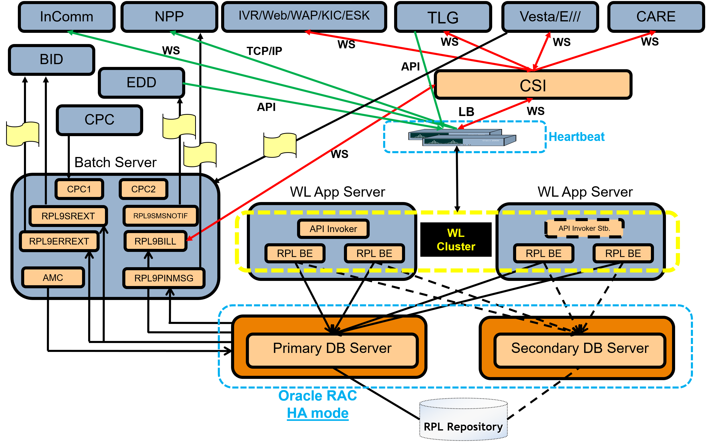

### High Level Integration Architecture

CSI functions as the middleware for all front-end applications that interact with the Payment Broker (PB) through API calls. The interaction flow is structured as follows:

* **API Exposure:** All Payment Broker APIs are exposed to CSI via Web Services. From the perspective of PB, CSI is the sole client.
* **Front-End Interaction:** All front-end applications invoke the CSI Web Services, which in turn call the Payment Broker Web Services.

**Notes:**

* **JMS Messaging for TLG:** The communication between PB and TLG (utilizes Java Message Service (JMS) messaging, rather than CSI Web Services. This ensures reliable and asynchronous message delivery between PB and TLG.
* **Direct API Calls to E///:** The interaction between PB and E/// (Ericsson) is facilitated through direct API calls, bypassing CSI. This direct communication ensures efficient and streamlined data exchange between PB and Ericsson systems.

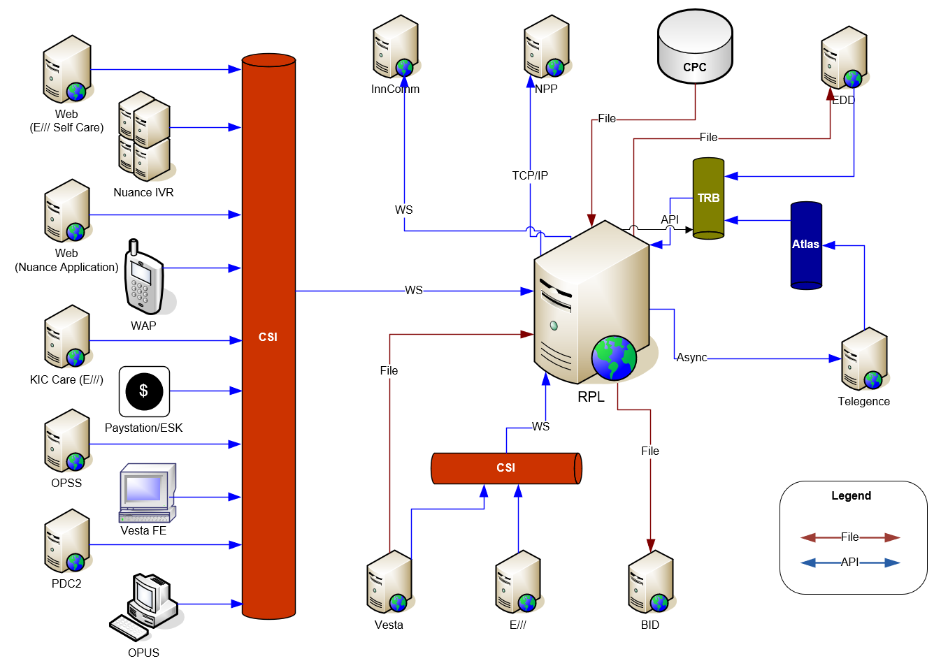

## Current Active – Passive (A/P) On-Prem Architecture

The Payment Broker (PB) application was initially designed with an Active/Passive (A/P) Geo-Redundant High Availability architecture, distributed across two geographically separated datacenters (DC1 and DC2). The target architecture after migration to FlexCloud will be distributed across FlexCloud Zones.

This architecture ensures continuous availability and disaster recovery capabilities.

**Architecture Overview:**

* **Primary Datacenter (DC1):** DC1 handles 100% of the transaction processing and replicates data to DC2.
* **Secondary Datacenter (DC2):** DC2 remains on standby, ready to take over transaction processing in the event of a failure at DC1.
* **Failure Recovery:** The system is designed to achieve failure recovery within a sub-minute timeframe, ensuring a seamless experience for users. Oracle Data Guard is utilized for database replication from DC1 to DC2, and in the event of a failure, replication can occur from DC2 back to DC1.

**Key Components and Processes:**

* **Load Balancer (LB):**
  + **Input Routing:** All inputs are routed by the Load Balancer between the datacenters.
  + **Failure Detection:** The Load Balancer monitors predefined criteria to detect failures at DC1. Upon detection, it redirects 100% of the inputs to DC2.
  + **Capacity Management:** Each datacenter is equipped to handle 100% of the transaction load independently.
* **Database Replication:**
  + **Data Guard:** Utilizes unidirectional replication to synchronize the primary databases at DC1 with the disaster recovery (DR) databases at DC2.
  + **Failover:** In the event of a failure at DC1, Data Guard facilitates the failover process, ensuring continuity of database operations at DC2.
* **API Routing:**
  + **Primary Routing:** The Load Balancer routes all online API requests to DC1.
  + **Failover Routing:** In the event of a failure at DC1, the Load Balancer redirects API requests to DC2.
* **File Replication:**
  + For files originating from Ericsson (E///), the Hadoop Distributed File System (HDFS) is used in conjunction with the EMC storage replication utility to replicate files from DC1 (Master) to DC2 (Passive).
* **Disaster Recovery Testing:**
  + **Requirement:** Regular testing of the disaster recovery (DR) processes is required to ensure the system's readiness and reliability in the event of a failure.

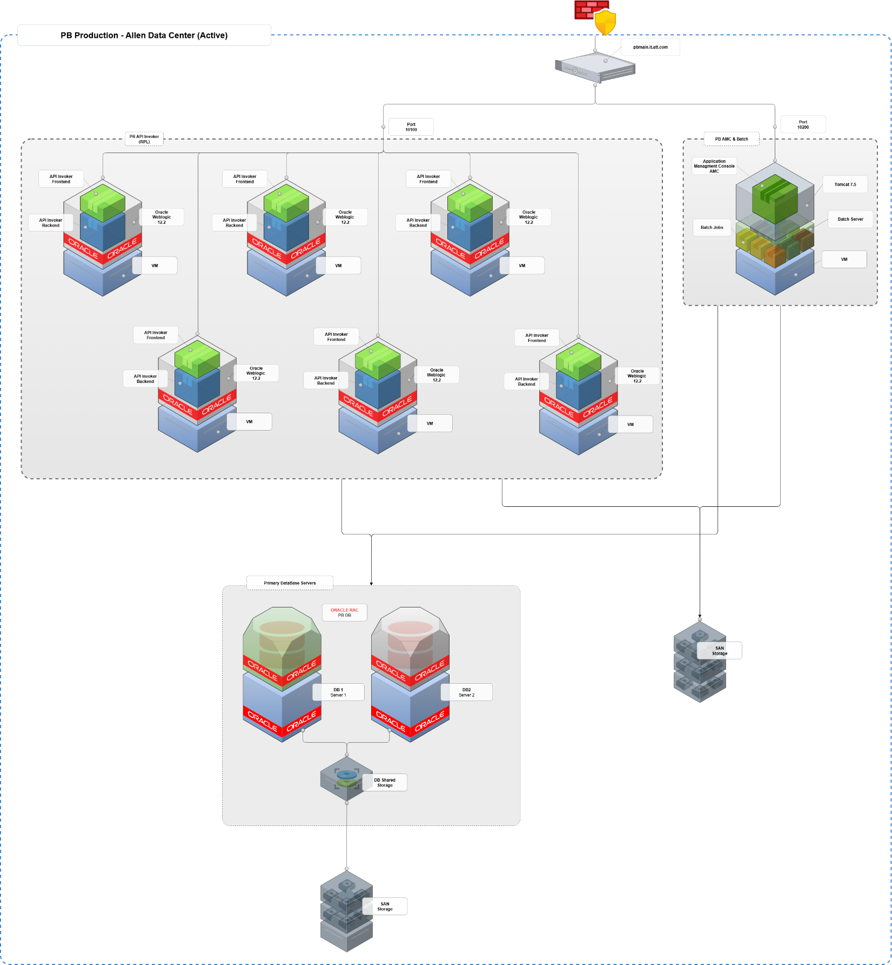

Figure 1. Current On-Prem Architecture

## Active – Passive (A/P) FlexCloud-Based Architecture

The Payment Broker (PB) application will be migrated to FlexCloud, leveraging separate zones to ensure high availability, disaster recovery, and scalability. This architecture will replace the previous geographically distributed datacenters with FlexCloud zones.

Key Components and Processes:

1. **Multi Zones Deployment:**
   * **Primary Zone:** The primary zone will handle 100% of the transaction processing.
   * **Secondary Zone:** The secondary zone will remain on standby, ready to take over transaction processing in the event of a failure in the primary zone.
2. **API Requests Routing:**
   * **Zone Traffic Routing:** ATT internal routing solution will be used to redirect traffic to the primary or secondary zone. It will monitor the health of endpoints and redirect traffic based on predefined criteria.
3. **Database Replication:**
   * **Oracle Database 19c:** Utilizes Oracle Data Guard for replication of data. This ensures data consistency and availability across Data Centers.
   * **Replication Strategy:** Data will be replicated from the primary Data Center to the secondary Data Center using Oracle Data Guard replication services
4. **File Replication:**
   * **FlexCloud Files replication:** For disaster recovery and failover the Files across Flex Cloud Zones will be replicated using File RSync. This ensures that file data is replicated and available in the secondary zone during failover events.
5. **Disaster Recovery Testing:**
   * **Regular Testing:** Disaster recovery drills will be conducted using Site Recovery to validate the replication and failover strategy. This ensures the system's readiness and reliability in the event of a failure.

**Benefits of FlexCloud-Based Architecture:**

* **High Availability:** FlexCloud lacks the concept of availability zones or failover groups, however we will implement a multi-instance application architecture with Software Defined Load Balancing for traffic in the FlexCloud Zone to ensure resilience and continuous availability and minimal downtime.
* **Scalability:** FlexCloud's infrastructure allows for scalable deployment, accommodating growing transaction volumes and user demands.
* **Security:** Compliance with AT&T's Technical Security Standards (TSS) and FlexCloud's robust security features enhance the overall security posture of the PB application.
* **Efficiency:** Software defined load balancing mechanisms streamline operations and improve system efficiency.



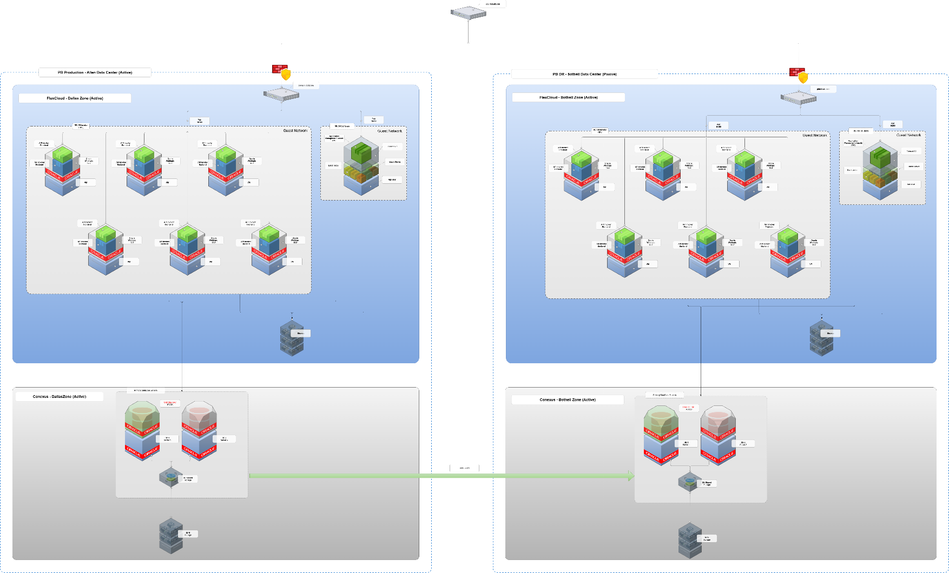

## Software Components

The following is a list of all 3rd party software components installed on PB servers that need to be upgraded to current approved versions.

|  |  |  |  |  |
| --- | --- | --- | --- | --- |
| **3rd Party Software Name** | **3rd Party Software Code** | **Current Version** | **AT&T TSS Version** | **Core Version** |
| Red Hat Enterprise Linux | RHEL | 6.x (64bit) | 8.x (64bit) | 8.x for APP 8.x for DB |
| Java Standard Edition Development Kit | Oracle JDK | 1.7.0_80 | 1.8.0_xx 11.0.x | 1.8.0_281 |
| Java Runtime Edition | Oracle JRE | 1.7.0_80 | 1.8.0_xx | 1.8.0_281 |
| Oracle RAC | Oracle RAC | 11g (11.2.0.4) | 19c | 12.2.0.4 (19c) |
| Oracle Data Base Enterprise Edition | Oracle DB EE | 11g (11.2.0.4) | 19c | 12.2.0.4 (19c) |
| Oracle DataGuard | DataGuard | 11g (11.2.0.4) | 19c | 12.2.0.4 (19c) |
| Oracle Client | Oracle Client | 11g (11.2.0.4) | 19c | 12.2.0.4 (19c) |
| Weblogic Server Enterprise Edition | Weblogic EE | 12.1.2  12.1.3 | 12.2.1.4 | 12.2.1.4 |
| RHEL Tomcat | RHEL (Apache) Tomcat | 7.0.23 | 9.0.x | 9.x |
| Tivoli Workload Scheduler | TWS | 8.6 | 9.x | 9.x |
| Internet Browser | IE – Retired  MS Edge  Firefox | IE – Retired  MS Edge Chromium  Firefox 91.x | MS Edge Chromium  Firefox 91.x | MS Edge Chromium  With Compatibility Mode IE 11* |
| ACE Framework | ACE | 6.2 | ** | 6.4.6 |
| Apache Ant | ant | 1.8.4 | 1.9.x | 1.9.4 |
| Apache Commons | commons | 3.2.2 |  | 3.2.2 |
| ANTLR | antlr | 4.4 | ** | 4.4 |
| ASN.1 | asn.1 | 8.4.0 | ** | 11.1 for C  8.4 for Java |
| AspectJ | aspectj | 1.7.1 | 1.x | 1.9.7 |
| BCEL | bcel | 5.2 | ** | 6.5 |
| GNU Bison | bison | 2.4.1 | ** | 3.8.2 |
| Boost | boost | 1.41.0 | ** | 1.77 |
| Cobertura | cobertura | 1.9.4.1 | ** | 2.1.1 |
| DMExpress | dmexpress | 7.9_64b | 7.x | 9.1 |
| Doxygen | doxygen | 1.6.1 | ** | 1.8.5.4 (GNU) |
| Flex | flex | 2.5.35 | ** | 2.5.37 |
| GNU GMP | gmp | 4.3.1 | ** | 6.2.1 |
| International Components For Unicode | icu | 4.2.1 | ** | 69 |
| J2SSH Maverick | j2ssh | 1.2.12 | ** | 1.5.5 |
| .NET Framework | .NET | 3.x/4x | 4.x | 4.5 |
| Intel Compiler - Parallel Studio XE | Intel compiler | XE 2013 (ICC) – 13.1.3 | ** | 2020.1.1.217 |
| Make | Make |  |  | 3.82-24.el7.x86_64 |
| Eclipse IDE | eclipse | 3.7.2 | 4.x | 4.9.0 |
| Apache Struts | struts | 1.x | 2.x | 2.5.26 |
| JUnit | junit | 3.8.2 | 4.x | 6.2 |
| GNU ncurses | ncurses | 5.7 | ** |  |
| OpenSSL | openssl | 1.0.0i, 1.0.1e | * | RHEL OS Upgrade |
| OpenSSH | openssh | 5.3 p1 | 8.x  7.x  6.x | RHEL OS Upgrade |
| Ossasn | ossasn | 1 | ** |  |
| Gemfire_client | Gemfire_client |  |  | 70 |
| Perl | perl | 5.10.1 | ** | 5.16.3 |
| Python | Python | 3.x |  | 3.x |
| PMD | pmd | 4.3 | ** |  |
| Apache POI | poi | 1.10.0 | 5.x  1.x * | 4.1.1 |
| Axis for SOAP APIs | axis | 1.x |  | Migrate out of Axis |
| Voltage | voltage | 510_c | 6.x  5.x * | 6.21 |
| Voltage | voltage | 510_java | 6.x  5.x * | 6.21 |
| Xalan C | xalan-c | 1.11.0_13 | ** | 1.11 |
| Xalan Java | xalan-j | 2_7_0 | 2.x | 2.71 |
| Xerces C | xerces-c | 3.1.1 | 3.x | 3.14 |
| Xerces Java | xerces-j | 2_11_0 | 2.x | 2.11 |
| XQilla | xqilla | 2.2.4 | ** | 2.3.0 |
| Connect:Direct Secure+ | Connect:Direct Secure + | 4.1 | 6.2.x | 6.2.x |

* Not supported by AT&T or it is retired.

** Not available in TSS and requires TSS exception.

## Amdocs Foundation Components

|  |  |
| --- | --- |
| **Foundation Components** | **Version** |
| ASM | 9.0_PB3_HF17 |
| AMC | 9.0.0.PB07 |
| AIF | 9.0.0.pb00_hf35 |
| APM | 9.2.0.pb01 |
| XPI | 9.0_PB07_HF27 |
| XPS | 9.0_PB3_HF17 |
| AMF | 9.2_PB_1_HF10 |

## PMX Upgrade Plan



# Assumptions, Dependencies

## Assumptions

### RPL 9.3.110 Certification on FlexCloud

* + The Certification should be performed on FlexCloud NON-PROD env and any issues identified must be addressed accordingly with help of Core team.

### Operational Changes

* + To provide all required changes

### Release – DB & APP

1. **Testing Environment Build:**
   * **Provisioning:** New testing environments will be provisioned on FlexCloud to facilitate comprehensive testing and validation of the upgrade process.
   * **Objective:** Ensure that the testing environments accurately replicate the production environment to identify and resolve any issues prior to deployment.
2. **Dual CC and Dual Certification Support:**
   * **Requirement:** Dual (CC) and dual certification support are required to ensure compatibility and compliance with security standards.
3. **Upgrade Completion:**
   * **Timeline:** The upgrade will be completed within a single release cycle.
   * **Flash Cut Approach:** The upgrade will be executed as a flash cut, eliminating the need to maintain code in two different Java versions. This approach ensures a seamless transition to the new version.
4. **Environment Upgrades:**
   * **Scope:** Both production (prod) and non-production (non-prod) environments will be upgraded. This includes the primary production environment, non-production environments, and the pre-production lab (PLAB).
   * **Objective:** Ensure consistency and compatibility across all environments to facilitate smooth deployment and operation.
5. **Oracle Database Upgrade:**
   * **Scope:** The upgrade of the Oracle Database is included in the scope of this release.
   * **Objective:** Migrate to Oracle Database 19c to leverage advanced features, improved performance, and enhanced security.
6. **Database Server Upgrades:**
   * **Scope:** Database servers are included in the scope of the release, ensuring that the infrastructure supports the upgraded database version.
   * **Objective:** Enhance the performance, reliability, and security of the database infrastructure.
7. **Media and Licenses:**
   * **Provisioning:** All required media and licenses will be in place for the 3PSW (Third-Party Software) team to commence the upgrade work.
   * **Objective:** Ensure that all necessary resources are available to avoid delays and facilitate a smooth upgrade process.
8. **Comprehensive Upgrade:**
   * **Scope:** The upgrade encompasses all environments (prod, non-prod, and PLAB) to ensure uniformity and compatibility across the entire system.
   * **Objective:** Achieve a seamless and efficient upgrade process, minimizing downtime and ensuring continuity of operations.

## Dependencies

### Dependent PIDs on PMX Upgrade

Not Applicable

### Impacted applications

|  |  |  |
| --- | --- | --- |
| **MOTS ID** | **Application Name** | **Impact: CODE, TEST Only, TEST SUPPORT Only** |
| 19206 | Payment Broker (PB) | CODE, CONFIG, TEST |
| N/A | BlackHawk  BlackStone  Incomm  Ericsson  Vesta | External vendors that PB interfaces with - test support |
| 17765 | CPC | Test support |

### Impacted interfaces

**We are not addressing Securing Interfaces as part of this project. We need to follow up on this Subject!**

|  |  |  |
| --- | --- | --- |
| **MOTS ID** | **Application Name** | **Impact: CODE, TEST Only, TEST SUPPORT Only** |
| 17689 | EDD | Test support |
| 14726 | GCP-EDN | Test support |
| 22509 | GRID-GDDN | Test support |
| 18172 | NPP-C | Test support |
| 18193 | TLG-MOB | Test support |
| 20182 | CSI-Customer Care | Test support |
| 19205 | DDA | Test support |
| 17790 | ESK, SSPK, SSK, GSK, rsIQ | Test support |
| 14726 | GCP-EDN | Test support |
| 22747 | Nuance IVR | Test support |
| ~~18187~~ | ~~Torch~~ | ~~Test support~~ |

### CSI migration to FlexCloud

# Traceability

|  |  |  |
| --- | --- | --- |
| # | Traceability |  |
| 1 | DB changes | * Yes |
| 2 | Internal interface changes | * No (YES for TLS v1.3) |
| 3 | External interface changes | * Yes for TLS v1.3 and C:D upgrade |
| 4 | Performance testing | * Yes |
| 5 | Regression Testing | * Yes |
| 5 | E2E testing | * Yes |
| 6 | Security Testing | * Yes |

# Operational Impact

|  |  |  |
| --- | --- | --- |
| Questions | Description | Yes/No/Not Identifiable |
| Architectural Changes | Migration to FlexCloud Cloud Architecture | Yes |
| System Interface Changes | Enable TLS 1.3 for all interfaces | Yes |
| Product Upgrades | Product like Syncsort, Vertex etc. Version changes or upgrades | Yes |
| Platform Upgrades & Migration | Platform like Oracle, Linux upgrades  Or Migration of platform like moving from Unix to Linux | Yes |
| DB Changes | Any Change to DB tables,  New table addition to Golden Gate,  Primary Key updates | No |
| Infra Changes | New Daemons, Any Manual Monitoring,  Any Manual reconciliation | No |
| New Application/Module | New topic, New Module like account management | No |
| File Transfer Changes or Validation Changes | To enable Connect: Direct Secure + Changes | Yes |
| New API’s / API Configuration Changes | New APIs or any configuration Change for API | No |
| Migration of Data | Migrating data from external client,  Update of data in our DB  One-time scripts, or repetitive scripts  E.g. Update of account type or any other field for a customer for a project. | No |
| Manual Script Runs | Any Manual Script Run required to update or validate data in Production | No |
| **Monitoring (Dynatrace or TAPM)** | **Setup & Configuration (Dynatrace or TAPM)** | **YES** |